**Q.1. Using object-oriented databases create the following types:**

1. **AddrType (Pincode:number, Street:char, City:char, State:char)**
2. **BranchType (address: AddrType, phone1: integer, phone2: integer)**
3. **AuthorType (name:char, address: AddrType)**
4. **PublisherType (name:char, address:AddrType, branches:BranchType)**
5. **AuthorListType as varray, which is a reference to AuthorType**

**Next create the following tables:**

**Branch of BranchType**

**Authors of AuthorType**

**Books (title:varchar,year:date,published_by ref Publishertype, auhtors AuthorListType)**

**Publishers of PublisherType**

**SQL Query:**

Create or replace type AddrType1 as object(

Pincode number(5),

Street char(20),

City varchar2(50),

state varchar2(40),

no number(4) );

create or replace type BranchType as object(

address AddrType1,

phone1 integer,

phone2 integer );

create or replace type BranchTableType as table of BranchType;

create or replace type AuthorType as object(

name varchar2(50),

addr AddrType1 );

create table authors of AuthorType;

create or replace type AuthorListType as varray(10) of ref

AuthorType;

create or replace type PublisherType as object(

name varchar2(50),

addr AddrType1, branches BranchTableType);

create table Publishers of PublisherType NESTED TABLE branches

STORE as branchtable;

create table books(

title varchar2(50),

year date,

published_by ref PublisherType,

authors AuthorListType);

insert into Authors values('stallings',

AddrType1(5002,'sstreet','pune','mha',04));

insert into Authors values('stallings',

AddrType1(7007,'sstreet','mumbai','mha',1007));

insert into Authors values('Navathe',

AddrType1(7008,'nstreet','nasik','mha',08));

insert into Authors values('Dhumdhare',

AddrType1(7003,'dstreet','mumbai','mha',1003));

insert into Authors values('Dhumdhare',

AddrType1(7008,'sstreet','mumbai','mha',1007));

insert into Authors values('Aho',

AddrType1(7006,'nstreet','mumbai','mha',1006));

insert into Authors values('rabiner',

AddrType1(8002,'dstreet','pune','mha',1003));

insert into Authors values('Dhanovan',

AddrType1(8003,'dstreet','pune','mha',1003));

insert into Publishers values('tata',AddrType1(4002,'rstreet','mumbai','mha',03),

BranchTableType(BranchType(AddrType1(5002,'fstreet','mumbai','mha',03),23406,69896)));

insert into Publishers values('seth',

AddrType1(7007,'sstreet','mumbai','mha',1007),

BranchTableType(BranchType( AddrType1(7007,'sstreet','mumbai','mha',1007),4543545,8676775)));

insert into Publishers values('joshi',

AddrType1(7008,'sstreet','mumbai','mha',1007),

BranchTableType(BranchType(

AddrType1(1002,'sstreet','nasik','mha',1007),456767,7675757)));

insert into Publishers values('seth',

AddrType1(7002,'sstreet','pune','mha',1007),

BranchTableType(BranchType(

AddrType1(1002,'sstreet','pune','mha',1007),4543545,8676775)));

insert into Publishers values('chetana',

AddrType1(6002,'sstreet','nasik','mha',1007),

BranchTableType(BranchType(

AddrType1(6002,'sstreet','nasik','mha',1007),4543545,8676775)));

insert into books

select 'java','28-may-1983',ref(pub),AuthorListType(ref(aut)) from

Publishers pub,Authors aut where pub.name='joshi' and aut.name='Aho';

insert into books

select 'java','28-may-1983',ref(pub),AuthorListType(ref(aut)) from

Publishers pub,Authors aut where pub.name='chetana' and aut.name='stallings';

insert into books

select 'compiler','09-jan-1890',ref(pub),AuthorListType(ref(aut)) from

Publishers pub,Authors aut where pub.name='chetana' and aut.name='Dhanovan';

insert into books

select 'c','25-may-1983',ref(pub),AuthorListType(ref(aut)) from

Publishers pub,Authors aut where pub.name='tata' and aut.name='stallings';

Insert records into the above tables and fire the following queries:

1. List all of the authors that have the same pin code as their publisher:

**SQL Query:**

select a.name from Authors a, Publishers p where a.addr.pincode = p.addr.pincode;

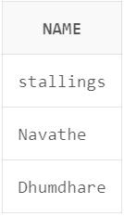

1. List all books that have 2 or more authors:

**SQL Query:**

SELECT b.title, COUNT(a.name) AS AuthorCount

FROM books b

JOIN Authors a ON b.authors_by.name = a.name

GROUP BY b.title

HAVING COUNT(a.name) >= 2;

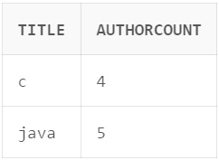

1. List the name of the publisher that has the most branches

**SQL Query:**

SELECT p.name AS PublisherName, COUNT(b.address) AS BranchCount

FROM Publishers p

JOIN TABLE(p.branches) b ON 1=1

GROUP BY p.name

ORDER BY BranchCount DESC

FETCH FIRST 1 ROW ONLY;

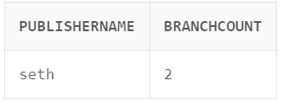

1. Name of authors who have not published a book

**SQL Query:**

SELECT a.name AS AuthorName

FROM Authors a

LEFT JOIN books b ON a.name = b.authors.name

WHERE b.title IS NULL;

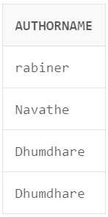

1. List all authors who have published more than one book

**SQL Query:**

SELECT a.name AS AuthorName

FROM Authors a

JOIN books b ON a.name = b.authors_by.name

GROUP BY a.name

HAVING COUNT(b.authors_by.name) > 1;

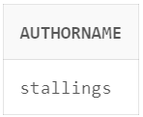

f) Name of authors who have published books with at least two different publishers

**SQL Query:**

SELECT a.name AS AuthorName, b1.title as BookName

FROM books b1, Authors a JOIN books b ON a.name = b.authors_by.name

GROUP BY a.name HAVING COUNT(b.authors_by.name) > =2;

